**Hotel Management System Raw requirement Document**

**Project Overview**

This document captures the raw requirements for a comprehensive hotel management system. It outlines the desired features and functionalities from the perspective of both hotel guests and staff, aiming to enhance the guest experience, streamline operations, and increase revenue.

We have conducted two elicitation interviews with the stakeholder on Feb 25th, 2024 and March 2nd respectively. The requirements were mainly focus following components:

* Online Booking and Reservation Management
* Check-In/Out and Room Assignment Automation
* Guest Profile Management
* Dynamic Pricing and Revenue Management
* Housekeeping and Maintenance Scheduling
* Customer Relationship Management (CRM) Integration
* Feedback and Review Management
* Data Analytics for Customer Insights

**Elicitation Strategies**

Elicitation strategies were employed through a combination of interviews and workshops involving participants from Group 4. These sessions were designed to gather comprehensive insights and requirements to inform the project's direction. All elicitations were conducted with group 4 throughout February and March. The whole elicitation and documenting process is continuous. We perform elicitation for each design document and polish the documents based on stakeholders’ feedback gathered from elicitation sessions.

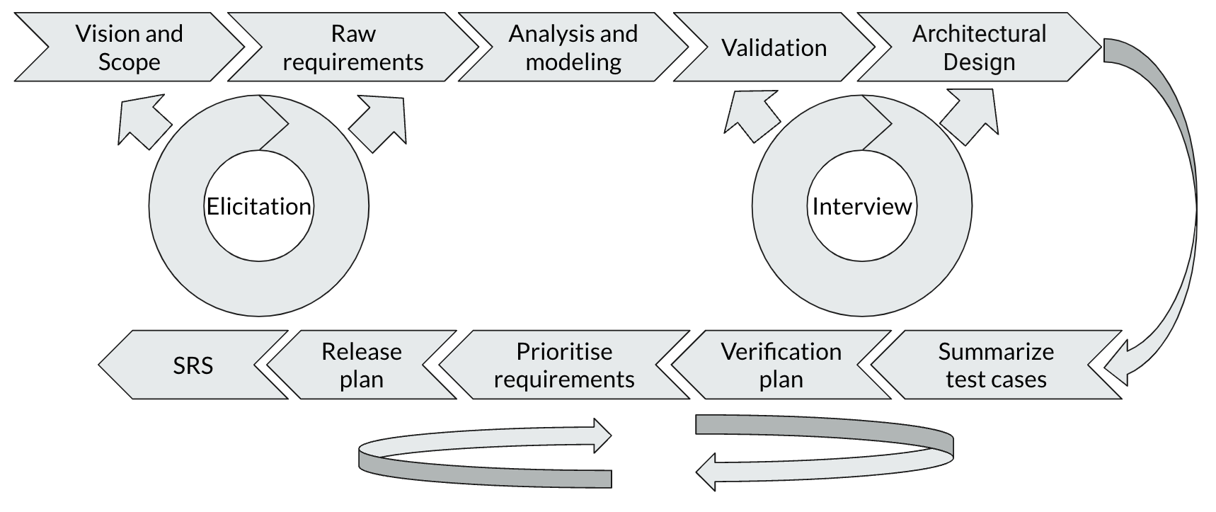

**Stakeholders**

* Hotel Guests
* Hotel Staff (Front Desk, Housekeeping, Maintenance, Management)
* Marketing Team
* IT Department
* Management Team

**Functional requirements**

**1. Online Booking and Reservation Management**

**User Story:** Guests shall be able to book a room online without the need to call the hotel, facilitating direct and hassle-free planning of their stay.

**User Story:** Guests shall have the capability to compare room types, availability, and rates on the hotel's online booking platform to make decisions that are well-informed and tailored to their needs and budget.

**User Story:** Guests shall receive immediate booking confirmation and relevant information about their stay via email or through the booking platform, ensuring they can feel secure about their reservation and plan their trip with all necessary details.

**User Story:** Hotel staff should have access to a centralized system to view and manage all reservations, allowing for efficient room allocation and preparation for guest arrivals.

**User Story:** The system should automatically update the inventory across all channels in real-time, ensuring that overbooking is prevented and room availability is accurately reflected, maximizing occupancy and revenue.

**2. Check-In/Out and Room Assignment Automation**

**User Story:** Guests shall be able to check in and out through their mobile device to save time and avoid waiting in lines at the front desk, enhancing the convenience of their hotel experience.

**User Story:** Guests shall have the option to use their mobile device to check in before arriving at the hotel, allowing them to bypass the front desk and proceed directly to their room, further streamlining their arrival process.

**User Story:** Guests shall be able to request room changes or upgrades through an app, enabling them to customize their stay conveniently without the need to interact with front desk personnel for such adjustments.

**User Story:** Hotel staff should be able to automatically assign rooms in the morning of check-in, ensuring that all guests receive rooms that best meet their individual preferences and status, thereby personalizing the guest experience from the start.

**User Story:** Hotel staff should have the capability to enable express check-out for guests, facilitating expedited departures, efficient billing management, and the swift preparation of rooms for incoming guests, thereby optimizing both guest satisfaction and room turnover efficiency.

**3. Guest Profile Management**

**User Story:** Hotel staff members shall have access to and the ability to update guest profiles to provide personalized services, thereby enhancing guest satisfaction.

**User Story:** The system shall automatically update a guest's order record once they make any service request, including room booking and room services, to help identify loyal and high-value customers.

**User Story:** Hotel staff shall have easy access to guest profiles during their stay so that they can offer personalized service and proactively meet guest needs.

**User Story:** Hotel staff shall be able to track guest feedback and preferences over time to continuously improve service quality and identify opportunities for personalized offers and services.

**User Story:** Guests shall have their previous stay preferences remembered and applied to future bookings to ensure each visit is personalized and requires minimal effort to meet their expectations.

**User Story:** Guests shall be able to update their profile and preferences online at any time, allowing the hotel to tailor their stay according to their current needs and preferences.

**4. Dynamic Pricing and Revenue Management**

**User Story:** The revenue manager shall implement dynamic pricing strategies based on demand, occupancy, season, and special events to maximize revenue.

**User Story:** Hotel staff shall adjust pricing based on real-time market data, ensuring that the hotel remains competitive and maximizes revenue potential.

**User Story:** Hotel staff shall identify and capitalize on high-demand periods through effective pricing strategies, aiming to optimize occupancy and overall revenue.

**User Story:** Guests shall have access to dynamic pricing offers, enabling them to book rooms at the best possible rates and ensuring they receive good value for their stays.

**User Story:** Guests shall receive notifications about special rates for periods they are interested in, allowing them to make timely bookings at reduced prices, enhancing the value proposition offered by the hotel.

**5. Housekeeping and Maintenance Scheduling**

**User Story:** The housekeeping manager shall efficiently schedule and track housekeeping tasks to ensure rooms are clean and well-maintained for guests.

**User Story:** Hotel staff shall receive real-time notifications of room status, allowing for efficient dispatch of housekeeping and maintenance to maintain rooms in optimal condition.

**User Story:** Hotel staff shall schedule preventative maintenance checks to proactively address potential issues and ensure all facilities are functioning properly for guests, enhancing the overall guest experience.

**User Story:** Guests shall have their rooms serviced at times convenient to them, ensuring the room remains clean and comfortable without disrupting their personal schedule.

**User Story:** Guests shall be able to request immediate housekeeping or maintenance services through an app, allowing for prompt resolution of any issues and ensuring a pleasant and uninterrupted stay.

**6. Customer Relationship Management (CRM) Integration**

**User Story:** The marketing manager shall leverage CRM data to create targeted marketing campaigns and loyalty programs for guests, enhancing engagement and driving loyalty.

**User Story:** Hotel staff shall leverage CRM data for targeted marketing campaigns, allowing the hotel to effectively reach potential guests with compelling offers and encourage repeat bookings.

**User Story:** Hotel staff shall analyze guest data to identify trends and preferences, aiming to continuously improve services and offerings, thereby enhancing overall guest satisfaction.

**User Story:** Guests shall be recognized as returning guests and receive loyalty rewards, making them feel valued and providing incentives to book directly with the hotel again, fostering a sense of loyalty and appreciation.

**User Story:** Guests shall receive personalized offers based on their interests and past stays, allowing them to enjoy tailored experiences and promotions that enhance their overall stay and satisfaction with the hotel.

**7. Feedback and Review Management**

**User Story:** The hotel manager shall collect and analyze guest feedback to identify areas for improvement and enhance guest satisfaction.

**User Story:** Hotel staff shall systematically collect and analyze guest feedback to identify areas for improvement and recognize successes, ensuring continuous enhancement of service quality and guest experience.

**User Story:** Hotel staff shall manage and respond to online reviews, maintaining a positive online reputation and addressing any misconceptions, thereby fostering trust and transparency with current and potential guests.

**User Story:** Guests shall be able to easily provide feedback during or after their stay, enabling them to share their experience and contribute to the hotel's improvement process, thus playing a role in enhancing service quality for themselves and future guests.

**User Story:** Guests shall receive acknowledgement from the hotel regarding their feedback, ensuring they feel heard and appreciated, and reinforcing the hotel's commitment to valuing guest input and striving for excellence in guest satisfaction.

**8. Data Analytics for Customer Insights**

**User Story:** The hotel manager shall utilize data analytics to gain insights into guest behavior, preferences, and trends, enabling informed decisions that improve services and tailor offerings to meet guest needs effectively.

**User Story:** Hotel staff shall use analytics to predict booking trends, allowing the hotel to adequately prepare for busy periods, optimize staffing, and allocate resources efficiently, ensuring guest needs are met without overextending resources.

**User Story:** Hotel staff shall measure guest satisfaction and compare it against industry benchmarks, to set realistic goals and develop strategies for continuous improvement, thereby enhancing the quality of service and guest experiences.

**User Story:** Guests shall expect the hotel to use their data responsibly to enhance stays, ensuring that their experiences are consistently improving and more closely aligned with their preferences, contributing to a more personalized and satisfying stay.

**User Story:** Guests shall receive suggestions for activities and services based on their interests, enabling them to discover new experiences tailored to their preferences during their stay, thus enhancing their overall satisfaction and engagement with the hotel.

**Non functional requirements**

**1. Performance Requirements**

* Response Time: The system should display pages and execute transactions within 2 seconds under normal load conditions.
* High Load Performance: Under peak load, the system must support up to 10,000 users simultaneously without degradation of performance.

**2. Usability Requirements**

* User Interface: The system should be intuitive and easy to use for individuals with no prior training, including guests and new hotel staff.
* Accessibility: The system must comply with the WCAG 2.1 AA standards to ensure accessibility for users with disabilities.

**3. Security Requirements**

* Data Encryption: All personal and payment information transmitted over the internet must be encrypted using at least TLS 1.2.
* Authentication: The system must support multi-factor authentication for administrative users to prevent unauthorized access.

**4. Scalability Requirements**

* Scalability: The system should be designed to easily accommodate growth, capable of scaling to support a 50% increase in user load without significant changes to the infrastructure.
* Database Scalability: The database should handle increasing amounts of data, with provisions for data archiving and purging based on retention policies.

**5. Reliability Requirements**

* Availability: The system should be available 24/7, with a targeted uptime of 99.9% excluding scheduled maintenance.
* Data Backup: Regular backups of all critical data must be performed, with the ability to restore operations within 4 hours in the event of a major failure.

**6. Maintainability Requirements**

* Upgradability: The system should be designed to allow easy updates and upgrades without significant downtime.
* Error Logging and Monitoring: The system must log errors comprehensively and support real-time monitoring to facilitate quick troubleshooting and resolution.

**7. Compatibility Requirements**

* Device Compatibility: The system should be compatible with the latest versions of major web browsers (e.g., Chrome, Firefox, Safari) and mobile platforms (iOS and Android).
* Integration Compatibility: The system must provide APIs for integration with external systems, such as CRM software, payment gateways, and third-party booking platforms.

**8. Data Privacy and Protection Compliance**

* GDPR and Local Privacy Laws: The system must comply with Canadian data protection laws, ensuring guests' personal information is collected, processed, stored, and shared in a lawful, fair, and transparent manner.